School District of Turtle Lake

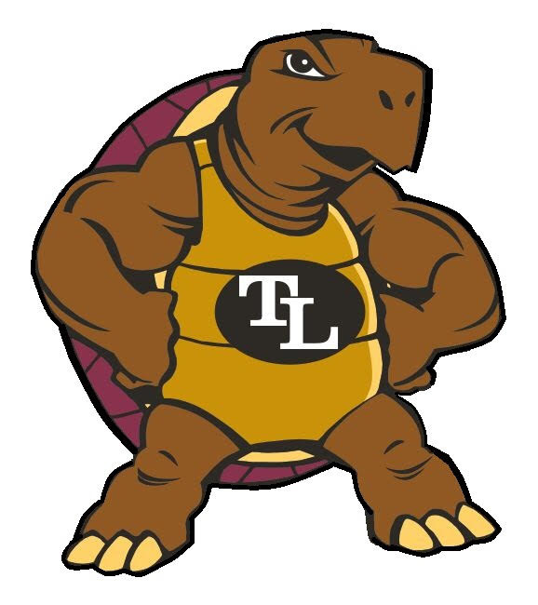

2023-2024
Continuity of
Services Plan
Revised October 2021, February 2022, August 2022
February 2023, and August 2023

The Turtle Lake School Community instills excellence in staff and students producing graduates with the knowledge and tools necessary to excel in all aspects of life.
The School District of Turtle Lake is dedicated to providing a safe environment for all students and staff. We understand that national and state guidance is optimal but not all guidance is practical in a small school setting. Barron County Schools and Barron County Public Health have worked together to develop this plan to ensure safety in the School District.
This plan is subject to change depending on the level of contagious diseases in the Turtle Lake School District.
The Turtle Lake School District will continue with in-person five-day week education. Students and families not comfortable with in-person education are welcome to apply for our Laker Online Virtual School. Under federal requirements, this plan will be revised every six months through September 2023. (August and February)
Health and Safety
Stay Home if Sick
- Vaccination is currently the leading prevention strategy to end the COVID pandemic.
- Parents should check their children's temperatures and be aware of any contagious disease symptoms before sending them to school. Students and staff should stay home when they have signs of any infectious illness.
- Barron County Public Health may hold Vaccination clinics in the school district.
- Face Coverings are optional and recommended for students and staff who are not fully vaccinated. Fully vaccinated is two weeks after the last dose in the series of the vaccine.
- Face Coverings should cover your nose and mouth, fit snugly against your face and nose, and not have any gaps.
- Students who test positive for COVID are encouraged to be quarantined for 5 days from the onset of symptoms and 24 hours fever-free.
- Students living in a house that has a positive COVID case are encouraged to be quarantined if not vaccinated or are showing any COVID symptoms.
  - If students are vaccinated and have no symptoms they may return to school.
  - A PCR test is recommended 48 hours from exposure to a positive person.
- If you are in contact with a positive case it is your responsibility to watch for symptoms. Any questions can be directed to public health.
  - Barron County Public Health 715-537-5691 ext. 6442
  - Polk County Public Health 715-485-8500
- Students will be sent home if they are experiencing symptoms of a communicable disease. Students should remain at home until they have been symptom-free for 24 hours. Parents will be asked to monitor for symptoms more carefully. Per WI State Statute 252.21
- Testing is available at all county health systems, pharmacies, and your healthcare providers.
- Students will be taught and reinforced on proper hand cleaning and sanitizing.
- Students are not allowed to use cleaning chemicals other than soap and water.
- Lunchroom
  - Student breakfast will be free for the 2023-2024 school year.
  - Barcodes on student IDs will be used to prevent touching a keyboard.
Educational Programming
- Staff are required to post daily assignments on Google Classroom in grades 3-12 and Class DOJO in grades PK-2.
- Students who are ill or quarantined will participate in homework posted online using Google Classroom.
- Students in grades K-12 will be assigned a Chromebook and should not share it with other students.
- Social and emotional support by the guidance counselor and Northlake’s Community Clinic
  - BEST Screener
  - Staff Training
  - Staff Referrals
  - Weekly/monthly discussions at all grades
  - Character Strong curriculum
  - Focus on a staff wellness program and use available resources
- Whole classrooms that are required to stay home will continue online education with Google Classroom.
  - Daily contact with students and parents
  - Weekly zoom meetings
  - Traditional grading
- Accommodations for special education will be made following the student's IEP.
Laker Online Virtual Charter School - Optional
Students and families who are not comfortable with in-person instruction may participate in our Laker Online Virtual Charter School. This program is coordinated by Turtle Lake School staff but is not taught by Turtle Lake School staff. Movement in and out of the programs is very difficult. If you choose this option, it is recommended that you stay in the program for the semester.
Operations
- Additional hand sanitizers are installed throughout the building.
- Sanitizing wipes will be provided in every room.
- Bottle filler stations are encouraged and students should bring water bottles.
- Ventilation using the building’s HVAC system will be increased.
- Classrooms, bathrooms, and locker rooms will be cleaned daily with an electrostatic sprayer that attaches a sanitizer to all surfaces.
- In the event of a long-term school closure, free meals will be provided.
Co-curricular
- All participants should have their water bottles and not use another student's bottle.
- During the WIAA tournament, play will follow WIAA guidance.

Communications
- The Remind app will be used for any district-wide school closure.
- Parents/guardians will be called if students are experiencing symptoms and need to be picked up.

